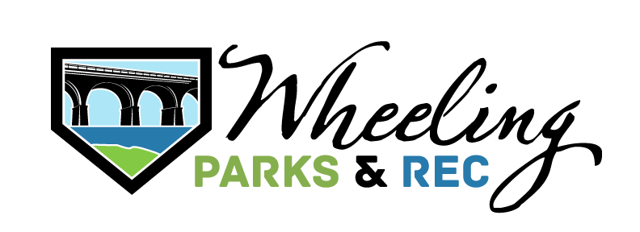
Youth Scholarship
Fund Application
The Wheeling Parks & Recreation Department maintains a scholarship fund to help Ohio County youth who do not have the financial means to participate in recreation programs, workshops, camps, and Mountaineer Leagues. Every effort will be made to accommodate your request. Qualifying applicants may only be required to pay a portion of the fee according to their financial ability.
Primary Adult
First & Last Name: ______________________________________________ DOB: ____ / ____ / ____
Relationship to Child: _________________________________________________________________
Address:_____________________________________________________________________________
City, State, Zip: ______________________________________________________________________
Phone: (Home) ___________________________________ (Cell) ______________________________
Email:_______________________________________________________________________________
Employment: _____________________________________ (W) Phone: ________________________

Secondary Adult
Secondary Adult’s Name: _______________________________________ DOB: ____ / ____ / ____
Relationship to Child: ___________________________ Phone: ______________________________

Dependents
First & Last Name: ______________________________________________ DOB: ____/ ____ / ____
Activity_________________________________Equipment_________________________________
First & Last Name: ______________________________________________ DOB: ____/ ____ / ____
Activity_________________________________Equipment_________________________________
First & Last Name: ______________________________________________ DOB: ____/ ____ / ____
Activity_________________________________Equipment_________________________________
First & Last Name: ______________________________________________ DOB: ____/ ____ / ____
Activity_________________________________Equipment_________________________________
First & Last Name: ______________________________________________ DOB: ____/ ____ / ____
Activity_________________________________Equipment_________________________________

Please list any allergies/medical conditions: ____________________________________________
________________________________________________________________________________________________________________________________________________________________________________________________________________________________________________________________________________________________________________________________________
H0USEHOLD INCOME Check one of the
Annual Adjusted Income
(Form 1040, line 37 or W2 income)

$
boxes below
Supply a copy of the most recent W2/1040 for all adults in the household.

Please complete IRS form 4506T of non-filing so we may verify non-filing status.

PLEASE STATE WHY YOU FEEL THAT YOU ARE ELIGIBLE FOR ASSISTANCE: __________________
__________________________________________________________________________________
__________________________________________________________________________________
__________________________________________________________________________________
(Additional information may be required.)

I, _______________________________, acknowledge that I have read and fully understand the information on registration guidelines and city policies. I realize inherent risks could be involved in these programs. Therefore, I shall not hold the City of Wheeling or its employees liable for injuries that might occur during these supervised programs. In the event of a program/event cancellation the participant will be credited the full amount of the program(s) for which you were approved.

Applicant’s Signature: ______________________________________ Date: _______________

Please return completed application and necessary documentation to:
City of Wheeling, Parks & Recreation Department
Attn: Youth Scholarship Fund Application
1500 Chapline Street
Wheeling, WV 26003 Or email: wheelingrec@wheelingwv.gov

FOR OFFICE USE ONLY:

Activity/Program Approved: __________________________________________________________
Date Participant is notified for approval: _____ / _____ / _____ Staff Initials: _________________
Amount to be paid by the Participant: $ ___________ Must be paid by (Date): ____ / ____ / _____
Date Paid: _____ / _____ / _____

Manner in which payment will be made (Circle one): VISA MC CASH CHECK #: ____________ OTHER: _______________________________________________________________________________________________
Approved for payment plan? (Circle one): Yes or No

Payment plan details: ____________________________________________________________________________________
________________________________________________________________________________________________________________________________________________________________________________________________________________

Additional Comments: ___________________________________________________________________________________
________________________________________________________________________________________________________________________________________________________________________________________________________________

Staff Approval Signature: _____________________________________ Date: _____ / _____ / ____

